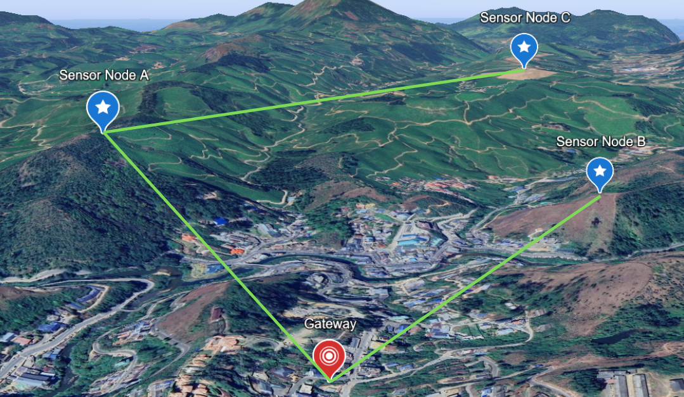
Legend:
Green Lines: Active Route
Black Lines: Failed/Damaged Routes
Blue Lines: Alternate Routes

What if A Fails?
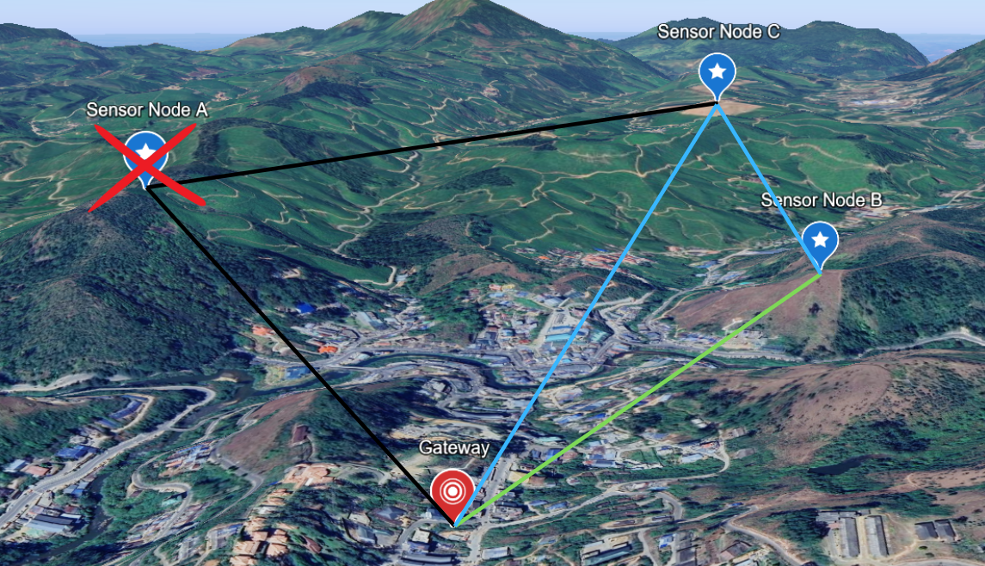
Legend:
Green Lines: Active Route
Black Lines: Failed/Damaged Routes
Blue Lines: Alternate Routes
Red Cross: Failed Node

